Dashboard 1: <https://public.tableau.com/profile/c3058#!/vizhome/CitiBike_w/Dashboard1>

Dashboard 2:

<https://public.tableau.com/profile/c3058#!/vizhome/CitiBike_15853382490170/Dashboard2>

Analysis:

For this analysis, I attempted to look at data for multiple months. However, the size of the data hindered my analysis. To ensure my computer could handle the data, I used only one month of the data, 2019-05 Citi Bike data. After cleaning the data, I built a few graphics to perform further analysis and find insights.

For one, more male users are utilizing Citi Bike than any other gender. Males made up of 722,242 of the 1,048,575 of the number of records. Using this insight, we can market more to female users or offer incentives to grow the female ridership. Looking further into the data, this pattern is also visible when looking at the Gender breakdown of the number of records per Gender. At peak times, around 8 am and 5 pm, this pattern is clearly visible. Another pattern that is clearly visible from this graphic is the significant drop in ridership during work hours 8 am-5 pm.

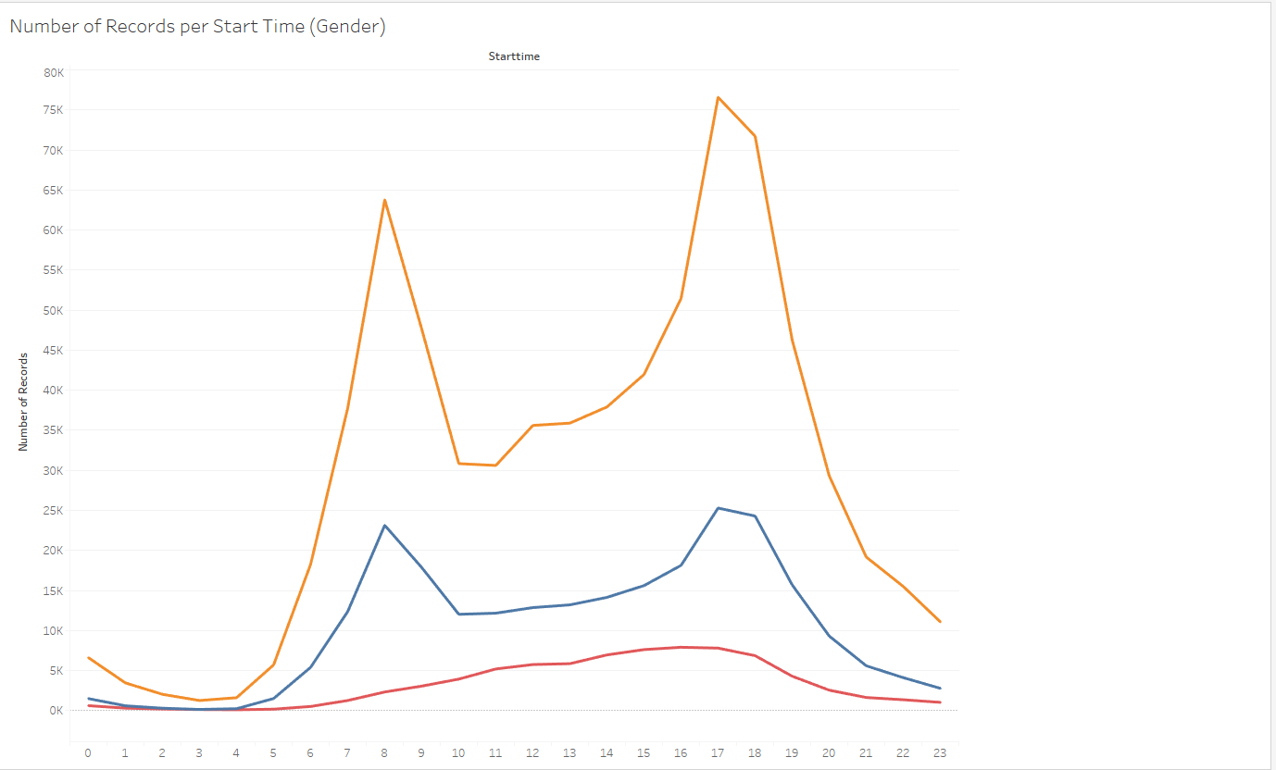

Another thing that jumped out to me was that Subscriber accounted for most the ridership throughout the day. More subscribers used the Citibike than nonsubscribers.

